Virtual Private Network (VPN)
Official URL: https://services.smsu.edu/TDClient/180/Portal/KB/Article/4160/Virtual-Private-Network-VPN
Category: Knowledge Base > Information Technology Services > Computer, Device, and Printing Support > Virtual Private Network (VPN)
Tags: vpn, network, access
_____________________________________________________

Use Cisco Secure Client (AnyConnect VPN) with Office 365 MFA on SMSU‑Issued Devices
Southwest Minnesota State University (SMSU) Information Technology Services (ITS) utilizes Office 365 multi-factor authentication (MFA) for AnyConnect VPN access. Since this application is not utilized by all staff members you will need to contact the TRC for assistance with installation. You will also be required to use O365 MFA with your full starID@minnstate.edu email and password. VPN is only available for use on SMSU issued devices and is not available for use on devices not purchased by the university or its departments.

Instructions on how to use VPN on your SMSU issued computer
The 0365 MFA sign-in for VPN is a familiar login window sequence when signing into VPN.
- In the Windows search bar or in the Mac Spotlight search type in "Cisco Secure Client"
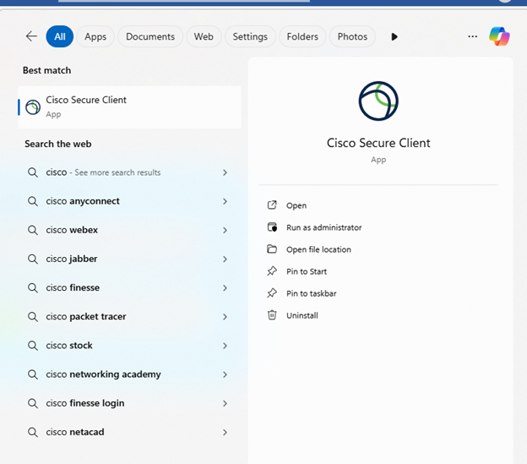
Figure 1: Windows search results showing Cisco Secure Client selected, with options to open and manage the app.
Figure 2: Screenshot
- The following screen should pop up, click connect and you will be redirected to a sign in screen
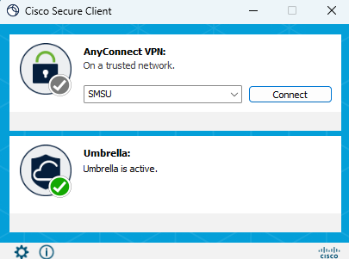
Figure 3: Cisco Secure Client window showing AnyConnect VPN ready to connect and Umbrella active.
- Sign in using yourstarid@minnstate.edu (Example: ab1234cd@minnstate.edu) and press “Next”.
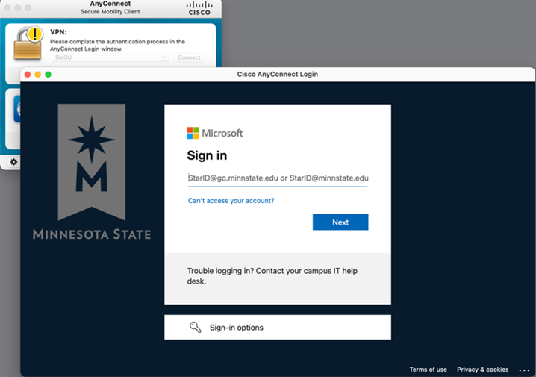
Figure 4: Cisco AnyConnect Login window open with a Microsoft sign-in interface, showing a field labeled ‘Sign in’ for StarID@go.minnstate.edu or StarID@minnstate.edu, along with a Next button and sign-in options.
- Enter your StarID password and press “Sign in”.
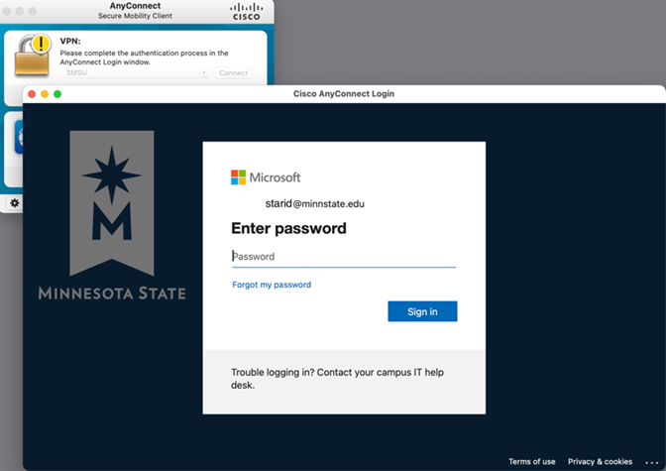
Figure 5: Screenshot of the Cisco AnyConnect Login window displaying a Microsoft sign-in page prompting for a password for a Minnesota State email account.
- Approve the sign in request using your verification method. The system will prompt in one of the following ways indicating how it is verifying the login attempt is really you. This is based on the preferred authentication method(s) you selected when enrolling.
Comply with the instructions in the prompt to gain access.
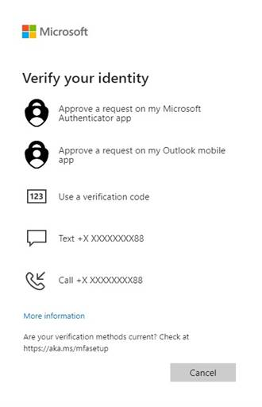
Figure 6: Microsoft verification screen offering options to confirm identity, including app approval, verification code, text, or phone call.
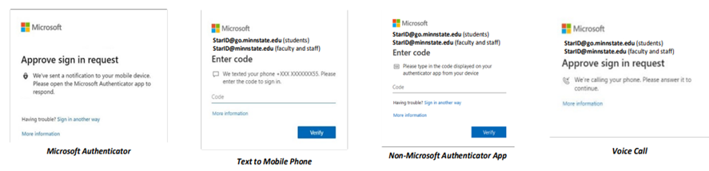
Figure 7: Microsoft authentication screens showing different sign-in verification options, including authenticator approval, text message code, app code entry, and voice call.”
- MFA prompts can be reduced using the “Stay Signed In” feature. This feature should never be used on shared or public devices. Use this feature only on your assigned Minnesota State device or a personal device that only you access and use. After your first login and MFA verification, check the “Don’t show this again” box then click “Yes”.
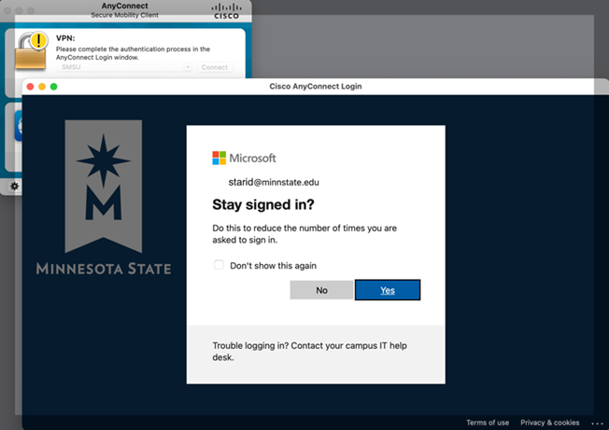
Figure 8: Cisco AnyConnect login window showing Microsoft ‘Stay signed in?’ prompt with Yes and No options.
In the event of a configuration issue in the AnyConnect client, it is possible to type in the full address for the VPN URL in the AnyConnect window to connect (anyconnect.smsu.edu).
Accessibility Review & Update Log:
- [ ] Content accuracy verified
- [ ] Color contrast checked
- [x] Image alt-text verified (screenshots auto-captioned)
- [x] Document structure and headings formatted (perfect bold, list bulletpoints and sequences preserved)

